HandyRef User Guide

* **Author:** Shouyuan Shi @ South China University of Technology
* **Latest Version：**<https://github.com/shishouyuan/HandyRefVBA>

# Introduction

HandyRef provides a handy way to insert Cross Reference in MS Word, just like copy and paste. "Copy" what you want to reference and "paste" it at the point where cross reference is needed. HandyRef abandons the long list for selecting reference items that MS Word uses and greatly speeds up the cross-reference process. HandyRef provides Ribbon and keyboard shortcut for the user, Figure 1‑1 shows the Ribbon that integrated in MS Word "Reference" Ribbon tab. By the way, HandyRef is open-source.

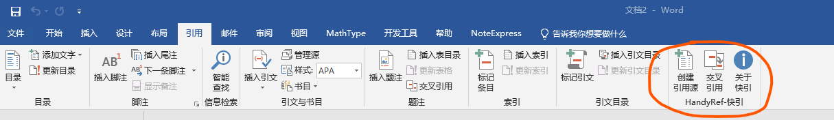

Figure ‑ HandyRef integrated in the "Reference" tab

# HandyRef Step by Step

Only 2 steps are needed to insert a cross reference with HandyRef, as in Figure 2‑1.

* Step 1：Select the contents that needed to be referenced, and click “Create Reference Point” or press “Ctrl+Alt+C”；
* Step 2：move the cursor to the point you want to insert a cross reference, and click “Insert Reference” or press“Ctrl+Alt+V”.You can repeat step 2 to insert multiple references that linked to same object.

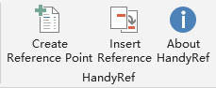

Figure ‑ Details of the HandyRef Ribbon buttons

# Setup of HandyRef

Please download the latest template file from the Release folder at <https://github.com/shishouyuan/HandyRefVBA>. Download "HandyRef-English.dotm" if you want an English UI. There are 2 ways to use HandyRef, but please ALWAYS MAKE SURE MACROS ARE ENABLED.

## Install HandyRef Globally

If you want to use HandyRef all the time, please choose this option.

It takes only one step to install HandyRef. Put “**HandyRef-English.dotm**” template file into the folder " %AppData%\Microsoft\Word\STARTUP " in your computer, restart MS Word and enable macros following the prompt.

## Temporarily Use of HandyRef

If you want to use HandyRef for a single file, please load the template file for a existing file or just double click the template file to create a new MS Word file that based on it.

# Claims

There is no guarantee given for HandyRef, and users take any consequence on their own.

HandyRef is open-source, but can only be used or distributed for non-commercial purpose.